Reinforcement Learning from Human Feedback (RLHF)

4.1 Introduction to RLHF

Reinforcement Learning from Human Feedback (RLHF) is a training paradigm used to align machine learning models—especially large language models—with human preferences. Instead of relying solely on labeled datasets, RLHF incorporates feedback from humans to guide model behavior.

It combines principles from reinforcement learning and supervised learning, enabling models to produce outputs that are more helpful, safe, and aligned with human expectations.

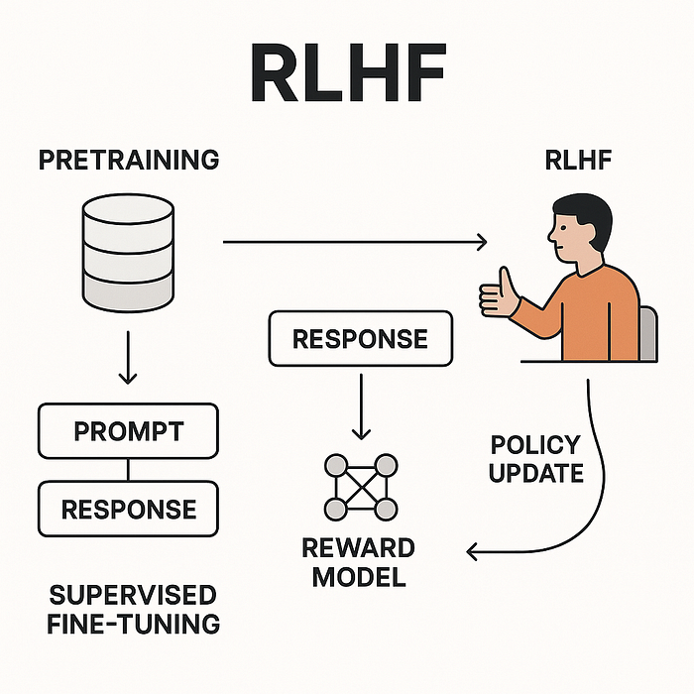

4.2 Motivation for RLHF

Traditional training methods have limitations:
- Models may generate factually incorrect or harmful content
- Lack of alignment with human values and intent
- Difficulty in encoding subjective preferences using labeled data

RLHF addresses these issues by directly incorporating human judgment into the training process.

4.3 Core Components of RLHF

4.3.1 Pretrained Model

A base model (e.g., a transformer-based language model) trained on large text corpora using supervised or self-supervised learning.

4.3.2 Human Feedback Collection

Humans evaluate model outputs and provide:
- Rankings (best vs worst responses)
- Scores (quality, relevance)
- Preferences (A better than B)

4.3.3 Reward Model (RM)

A separate model is trained to predict human preferences.
- Input: Prompt + model responses
- Output: Reward score

This model approximates human judgment.

4.3.4 Reinforcement Learning Optimization

The base model is fine-tuned using reinforcement learning to maximize the reward predicted by the reward model.

4.4 RLHF Training Pipeline

Step 1: Supervised Fine-Tuning (SFT)
- Train the model on high-quality human-written examples.

Step 2: Reward Model Training
- Collect human rankings of multiple outputs.
- Train a reward model to score responses.

Step 3: Policy Optimization
- Use reinforcement learning (e.g., PPO) to optimize the model.

4.6 Advantages of RLHF
- Aligns models with human preferences
- Improves response quality and safety
- Handles subjective tasks effectively
- Reduces harmful or biased outputs

4.7 Challenges in RLHF
- Human feedback is expensive and time-consuming
- Reward model may introduce bias
- Risk of reward hacking (model exploits reward model)
- Training instability in reinforcement learning

4.8 Applications of RLHF
- Chatbots and conversational AI
- Content moderation
- Code generation assistants
- Personalized recommendation systems

